1- Which of the following statement removes database including its related components? 0.5

A. DROP DATABASE  
B. DELETE DATABASE  
C. REMOVE DATABASE  
D. None of the mentioned

Ans : A

2- Which statement would add a column CGPA to a table Student which is already created 0.5

A. ALTER TABLE Student ADD COLUMN (CGPA NUMBER(3,1));  
B. ALTER TABLE Student CGPA NUMBER(3,1);  
C. ALTER TABLE Student ADD (CGPA NUMBER(3,1));  
D. Both A and C

Ans : C

1. Consider we have 30 employees where 20 of them belong to different departments and the rest don’t belong to any department. On the other hand, we have 4 departments where each of them have employees assigned to it. How many record will result by performing left outer join between Table Employee and Department? (Employee left join Department) 0.5

10

20

30

40

1. Consider we have 30 employees where 20 of them belong to different departments and the rest don’t belong to any department. On the other hand, we have 4 departments where each of them have employees assigned to it. How many record will result by performing right outer join between Table Employee and Department? (Employee right join Department) 0.5

10

20

30

40

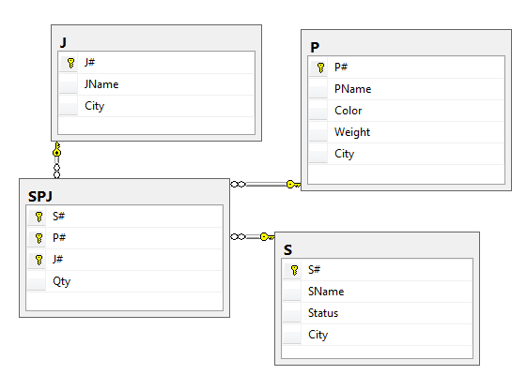

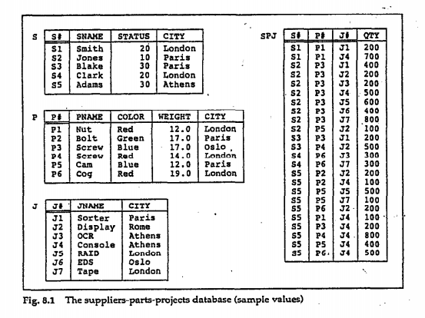

1. for each supplier, get supplier names and number of project they supplied where supplier and project not located on the same city .

select sname , COUNT(SPJ.j#)

from S,SPJ,J

where S.s#=SPJ.s# and SPJ.j#=J.j# and S.city != J.city

group by sname

incorrect choices:

select sname , COUNT(SPJ.j#)

from S,SPJ,J

where S.s#=SPJ.s# and SPJ.j#=J.j# and S.city != J.city

group by sname

select sname , COUNT(SPJ.j#)

from S,SPJ,J

where S.s#=SPJ.s# and SPJ.j#=J.j# or S.city != J.city

group by sname

select sname , COUNT(SPJ.j#)

from S,SPJ,J

where S.s#=SPJ.s# or SPJ.j#=J.j# or S.city != J.city

group by sname

6 - Given SPJ schema, Which of the following queries get the names of suppliers who supply parts for projects located in London or Paris.

1. select sname #correct answer

from S,SPJ,J

where S.s#=SPJ.s# and J.j#=SPJ.J#

and (J.city = 'London'or J.city = 'Paris')

1. select sname

from S,SPJ,J

where S.s#=SPJ.s# and J.j#=SPJ.J#

and J.city = 'London'or J.city = 'Paris'

1. select sname

from S,SPJ,J

where S.s#=SPJ.s# and J.j#=SPJ.J#

and (J.city = 'London'and J.city = 'Paris')

1. select sname

from S,SPJ,J

where S.s#=SPJ.s# and J.j#=SPJ.J#

and (S.city = 'London'or J.city = 'Paris')

1. select sname

from S,SPJ

where S.s#=SPJ.s#

and (S.city = 'London'or S.city = 'Paris')

7-Given SPJ schema, which of these sql statements don’t violate referential integrity constraint and entity constraint?

1. insert into SPJ values ('s1','p1','j1',300)
2. insert into SPJ values ('s6','p1','j5',300)
3. insert into SPJ values ('s2','p9','j5',300)
4. insert into SPJ values ('s1','p2','j5',300)// correct answer

8- Given SPJ schema, what’s the correct number of columns and tuples resulting from the following query:

select *

from P,S

where P.city != S.City

Correct Answer : 9 columns, 20 Tuples

Incorrect Answers :

8 columns, 20 Tuples

9 columns, 10 Tuples

1. columns, 18 Tuples

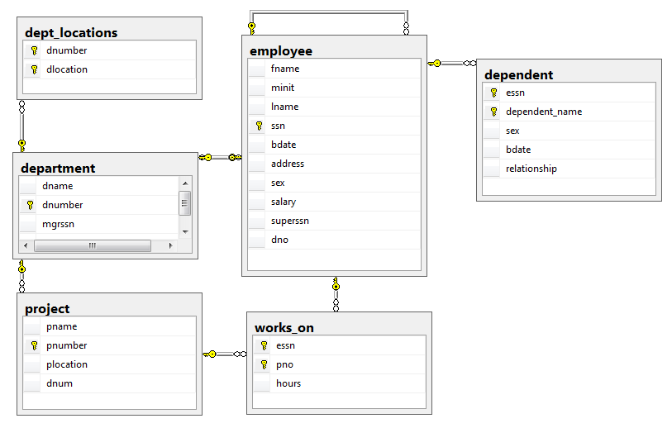

9- For each department whose average employee salary is more than $30,000, retrieve the department name and the number of employees working for that department.

Select dname, avg(salary) as avg_salary, count(ssn)as employeecount

From department, employee

Where dnumber=dno

group by dname

having avg(salary)>30000

incorrect choices:

Select dname, avg(salary) as avg_salary, count(ssn)as employeecount

From department, employee

Where dnumber=dno

having avg(salary)>30000

group by dname

///////////////////////////////////////////////////

Select dname, avg(salary) as avg_salary, count(ssn)as employeecount

From department, employee

Where dnumber=dno

group by dname

having avg_salary>30000

///////////////////////////////////////////////////////////

Select dname, avg(salary) as avg_salary, count(ssn)as employeecount

From department, employee

Where dnumber=dno

group by dname

having count(ssn)>30000

10- Consider the below table:  
Employee_Info

|  |  |  |
| --- | --- | --- |
| **ID** | **Department** | **Name** |
| 01 | Sales | Mark |
| 02 | Human Resources | John |
| 03 | Marketing | Suzy |
| 04 | Accounting | Adam |
| 05 | Engineering | Peter |
| NULL | NULL | NULL |

What will be the result of following query:  
  
SELECT ID, Department, Name  
FROM Employee_Info  
WHERE EXISTS (SELECT NULL)

a)

|  |  |  |
| --- | --- | --- |
| **ID** | **Department** | **Name** |
| 01 | Sales | Mark |
| 02 | Human Resources | John |
| 03 | Marketing | Suzy |
| 04 | Accounting | Adam |
| 05 | Engineering | Peter |

b) Error Message.

c)

|  |  |  |
| --- | --- | --- |
| **ID** | **Department** | **Name** |
| NULL | NULL | NULL |

d)

|  |  |  |
| --- | --- | --- |
| **ID** | **Department** | **Name** |
| 01 | Sales | Mark |
| 02 | Human Resources | John |
| 03 | Marketing | Suzy |
| 04 | Accounting | Adam |
| 05 | Engineering | Peter |
| NULL | NULL | NULL |

11-You need to display the names and job IDs of those employees who currently have a job title that is the same as their previous one. Which of the following queries will work?

1. SELECT employee_id , job_id, first_name, last_name

FROM employees

UNION

SELECT employee_id , job_id, first_name, last_name

FROM job_history;

1. SELECT employee_id , job_id, first_name, last_name

FROM employees

INTERSECT

SELECT employee_id , job_id, first_name, last_name

FROM job_history;

1. SELECT employee_id , job_id, first_name, last_name

FROM employees

UNION ALL

SELECT employee_id , job_id, first_name, last_name

FROM job_history;

1. SELECT employee_id , job_id, first_name, last_name

FROM employees

Except

SELECT employee_id , job_id, first_name, last_name

FROM job_history;

12- Given northwind schema , Get the distinct products categories shipped by 'United Package'.

Correct answer:

select distinct CategoryName

from dbo.Products,dbo.Orders,dbo.[Order Details],dbo.Shippers,dbo.Categories

where dbo.Categories.CategoryID=dbo.Products.CategoryID and dbo.Orders.OrderID=dbo.[Order Details].OrderID and dbo.Products.ProductID=dbo.[Order Details].ProductID and dbo.Orders.ShipVia= dbo.Shippers.ShipperID

and dbo.Shippers.CompanyName='United Package'

incorrect answers:

select distinct CategoryName

from dbo.Products,dbo.Orders,dbo.[Order Details],dbo.Shippers,dbo.Categories

where dbo.Categories.CategoryID=dbo.Products.CategoryID and

dbo.Orders.OrderID=dbo.[Order Details].OrderID and

dbo.Products.ProductID=dbo.[Order Details].ProductID

and dbo.Orders.ShipVia= dbo.Shippers.ShipperID

or dbo.Shippers.CompanyName='United Package'

select distinct CategoryName

from dbo.Products,dbo.Orders,dbo.[Order Details],dbo.Shippers,dbo.Categories

where dbo.Categories.CategoryID=dbo.Products.CategoryID or

dbo.Orders.OrderID=dbo.[Order Details].OrderID or

dbo.Products.ProductID=dbo.[Order Details].ProductID

or dbo.Orders.ShipVia= dbo.Shippers.ShipperID

and dbo.Shippers.CompanyName='United Package'

select distinct CategoryName

from dbo.Products,dbo.Orders,dbo.[Order Details],dbo.Shippers,dbo.Categories

where dbo.Categories.CategoryID=dbo.Products.CategoryID and

(dbo.Orders.OrderID=dbo.[Order Details].OrderID or

dbo.Products.ProductID=dbo.[Order Details].ProductID

or dbo.Orders.ShipVia= dbo.Shippers.ShipperID)

and dbo.Shippers.CompanyName='United Package'

select distinct CategoryName

from dbo.Products,dbo.Orders,dbo.[Order Details],dbo.Shippers,dbo.Categories

where dbo.Categories.CategoryID=dbo.Products.CategoryID and

(dbo.Orders.OrderID=dbo.[Order Details].OrderID or

dbo.Products.ProductID=dbo.[Order Details].ProductID

or dbo.Orders.ShipVia= dbo.Shippers.ShipperID)

and dbo.Shippers.CompanyName='United Package'

13-Given SPJ schema, which of the following SQL DDL query is correct for declaring S table, you must ensure that the status column can’t be below 10 and can’t be above 40 and all the columns can’t be null.

1. create table S

(

s# varchar(5),

sname varchar(20) not null,

status int not null check (status >= 10 and status <= 40),

city varchar(20) not null,

primary key(s#)

);

1. create table S

(

s# varchar(5),

sname varchar(20) not null,

status int not null check (status >= 10 and status <= 40),

city varchar(20) not null,

);

c-create table S

(

s# varchar(5),

sname varchar(20) not null,

status int not null check (status >= 10 and status <= 40),

city varchar(20) not null,

primary key(s#),

);

1. none of the above

14- which of the following queris Return a list of distinct customers (CustomerID,CompanyName)who has orders shipped to UK

1. select distinct customers.CustomerID,CompanyName

from dbo.Orders , Customers

where ShipCountry='UK' and Orders.CustomerID=Customers.CustomerID

1. select c.CustomerID,CompanyName

from Customers c

where exists (select * from orders where ShipCountry='UK')

1. select distinct CustomerID,CompanyName

from dbo.Orders , Customers

where ShipCountry='UK' and Orders.CustomerID=Customers.CustomerID

1. a and b